E-COMMERCE SHIPPING

DATA ANALYSIS

INDEX

|  |  |  |
| --- | --- | --- |
| **S.NO** | **TOPIC** | **PAGE NO** |
| 1 | INTRODUCTION | 3 |
| 2 | CODE | 4-17 |
| 3 | SUMMARY | 18 |
| 4 | REFERENCES | 19 |

INTRODUCTION

**What is E-Commerce shipping?**

E-commerce shipping is the way in which products ordered online are delivered to the location of the buyer. Usually businesses can work with e-commerce logistics providers to understand what works best for their business.

Logistics companies play an important and vital role in the success of the e-commerce business, as customer satisfaction is directly related to the handling of the shipment. The packaging and safe delivery of the product is a factor that keeps the customer happy and ordering more from the e-commerce site. An e-commerce business needs to have a strong and effective strategy in place for the shipping and delivery of goods and services, as this is a competitive differentiator as well in the market.

The most important functions of e-commerce logistics are warehousing and inventory management, order creation and waybill generation, transportation of orders and in-transit storage, handling delivery exceptions and finally reverse logistics. An essential part of transportation management lies in building an efficient supply chain from the six main modes of transportation: road, maritime, air, rail, intermodal, and pipeline. Understanding the strengths and weaknesses of each mode is paramount to building an effective supply chain.

Nowadays, consumers choose who to buy from based on their overall customer experience. Having the lowest price or best product no longer guarantees a sale. The e-commerce sites need to provide them with a faster delivery service to ensure customer satisfaction, which will ultimately boost the growth of the business. All three modes of shipping-land, air, and sea-play a major role in our economy. Each offers benefits that the other mode of transport might not offer. It is up to the Logistics to make a well-informed decision of choosing the right mode of shipping that will be beneficial.

Top E-Commerce sites in the world

1. amazon.com
2. ebay.com
3. rakuten.co.jp
4. aliexpress.com
5. Walmart.com

Top E-Commerce Logistics Companies in Global Market 2021

1. DHL
2. KENCO
3. CLIPPER
4. FEDEX
5. XPO

E-COMMERCE SHIPPING DATA ANALYSIS

In [1]:

**import** pandas **as** pd

**import** numpy **as** np

**import** matplotlib.pyplot **as** plt

**import** seaborn **as** sns

**import** warnings

warnings.filterwarnings('ignore')

**%**matplotlib inline

# Data Extraction

In [2]:

df**=**pd.read_excel('Project-Ecommerce Shipping Data Analysis (Python).xlsx') d**=**df.copy()

In [3]:

*#Ecommerce Shipping Dataset*

d

|  |  |  |  |  |  |  |  |  |  |
| --- | --- | --- | --- | --- | --- | --- | --- | --- | --- |
| Out[3]: |  | | | | | | | | |
|  |  | **ID** | **Warehouse_block** | **Mode_of_Shipment** | **Customer_care_calls** | **Customer_rating** | **Cost_of_the_Product** | **Prior_purchases** | **Produc** |
|  | **0** | 1 | D | Flight | 4 | 2 | 177 | 3 |  |
|  | **1** | 2 | F | Flight | 4 | 5 | 216 | 2 |  |
|  | **2** | 3 | A | Flight | 2 | 2 | 183 | 4 |  |
|  | **3** | 4 | B | Flight | 3 | 3 | 176 | 4 |  |
|  | **4** | 5 | C | Flight | 2 | 2 | 184 | 3 |  |
|  | **...** | ... | ... | ... | ... | ... | ... | ... |  |
|  | **10994** | 10995 | A | Ship | 4 | 1 | 252 | 5 |  |
|  | **10995** | 10996 | B | Ship | 4 | 1 | 232 | 5 |  |
|  | **10996** | 10997 | C | Ship | 5 | 4 | 242 | 5 |  |
|  | **10997** | 10998 | F | Ship | 5 | 2 | 223 | 6 |  |
|  | **10998** | 10999 | D | Ship | 2 | 5 | 155 | 5 |  |

10999 rows × 12 columns

In [4]:

d.shape

Out[4]:

(10999, 12)

In [5]:

Out[5]:

d.columns

Index(['ID', 'Warehouse_block', 'Mode_of_Shipment', 'Customer_care_calls', 'Customer_rating', 'Cost_of_the_Product', 'Prior_purchases',

'Product_importance', 'Gender', 'Discount_offered', 'Weight_in_gms', 'Reached.on.Time_Y.N'],

dtype='object')

In [6]:

d.head()

|  |  |  |  |  |  |  |  |  |  |
| --- | --- | --- | --- | --- | --- | --- | --- | --- | --- |
| Out[6]: |  | | | | | | | | |
|  |  | **ID** | **Warehouse_block** | **Mode_of_Shipment** | **Customer_care_calls** | **Customer_rating** | **Cost_of_the_Product** | **Prior_purchases** | **Product_import** |
|  | **0** | 1 | D | Flight | 4 | 2 | 177 | 3 |  |
|  | **1** | 2 | F | Flight | 4 | 5 | 216 | 2 |  |
|  | **2** | 3 | A | Flight | 2 | 2 | 183 | 4 |  |
|  | **3** | 4 | B | Flight | 3 | 3 | 176 | 4 | me |
|  | **4** | 5 | C | Flight | 2 | 2 | 184 | 3 | me |

In [7]:

d.tail()

|  |  |  |  |  |  |  |  |  |  |
| --- | --- | --- | --- | --- | --- | --- | --- | --- | --- |
| Out[7]: |  | | | | | | | | |
|  |  | **ID** | **Warehouse_block** | **Mode_of_Shipment** | **Customer_care_calls** | **Customer_rating** | **Cost_of_the_Product** | **Prior_purchases** | **Produc** |
|  | **10994** | 10995 | A | Ship | 4 | 1 | 252 | 5 |  |
|  | **10995** | 10996 | B | Ship | 4 | 1 | 232 | 5 |  |
|  | **10996** | 10997 | C | Ship | 5 | 4 | 242 | 5 |  |
|  | **10997** | 10998 | F | Ship | 5 | 2 | 223 | 6 |  |
|  | **10998** | 10999 | D | Ship | 2 | 5 | 155 | 5 |  |

In [8]:

d.info()

<class 'pandas.core.frame.DataFrame'> RangeIndex: 10999 entries, 0 to 10998 Data columns (total 12 columns):

# Column Non-Null Count Dtype

|  |  |  |  |  |
| --- | --- | --- | --- | --- |
| 0 ID | 10999 | non-null |  | int64 |
| 1 Warehouse_block | 10999 | non-null |  | object |
| 2 Mode_of_Shipment | 10999 | non-null |  | object |
| 3 Customer_care_calls | 10999 | non-null |  | int64 |
| 4 Customer_rating | 10999 | non-null |  | int64 |
| 5 Cost_of_the_Product | 10999 | non-null |  | int64 |
| 6 Prior_purchases | 10999 | non-null |  | int64 |
| 7 Product_importance | 10999 | non-null |  | object |
| 8 Gender | 10999 | non-null |  | object |
| 9 Discount_offered | 10999 | non-null |  | int64 |
| 10 Weight_in_gms | 10999 | non-null |  | int64 |
| 11 Reached.on.Time_Y.N | 10999 | non-null |  | int64 |

dtypes: int64(8), object(4) memory usage: 1.0+ MB

In [9]:

*#Warehouse Blocks*

np.sort(d['Warehouse_block'].unique())

Out[9]: array(['A', 'B', 'C', 'D', 'F'], dtype=object)

In [10]:

*#Mode of Shipment*

np.sort(d['Mode_of_Shipment'].unique())

Out[10]: array(['Flight', 'Road', 'Ship'], dtype=object)

# Data Cleansing

In [11]:

df.isnull().sum().sum()

Out[11]: 0

In [12]:

d.isnull().sum()

Out[12]:

ID 0

Warehouse_block 0

Mode_of_Shipment 0

Customer_care_calls 0

Customer_rating 0

Cost_of_the_Product 0

Prior_purchases 0

Product_importance 0

Gender 0

Discount_offered 0

Weight_in_gms 0

Reached.on.Time_Y.N 0

dtype: int64

# Data Transformation

In [13]:

d.drop(['ID','Prior_purchases'],axis**=**1,inplace**=True**) d

|  |  |  |  |  |  |  |  |  |  |
| --- | --- | --- | --- | --- | --- | --- | --- | --- | --- |
| Out[13]: |  | | | | | | | | |
|  |  | **Warehouse_block** | **Mode_of_Shipment** | **Customer_care_calls** | **Customer_rating** | **Cost_of_the_Product** | **Product_importance** | **Gender** | **D** |
|  | **0** | D | Flight | 4 | 2 | 177 | low | F |  |
|  | **1** | F | Flight | 4 | 5 | 216 | low | M |  |
|  | **2** | A | Flight | 2 | 2 | 183 | low | M |  |
|  | **3** | B | Flight | 3 | 3 | 176 | medium | M |  |
|  | **4** | C | Flight | 2 | 2 | 184 | medium | F |  |
|  | **...** | ... | ... | ... | ... | ... | ... | ... |  |
|  | **10994** | A | Ship | 4 | 1 | 252 | medium | F |  |
|  | **10995** | B | Ship | 4 | 1 | 232 | medium | F |  |
|  | **10996** | C | Ship | 5 | 4 | 242 | low | F |  |
|  | **10997** | F | Ship | 5 | 2 | 223 | medium | M |  |
|  | **10998** | D | Ship | 2 | 5 | 155 | low | F |  |

10999 rows × 10 columns

In [14]:

*#Data sorted by Warehouse block column*

d['Warehouse_block']**=**np.sort(d['Warehouse_block']) d

|  |  |  |  |  |  |  |  |  |  |
| --- | --- | --- | --- | --- | --- | --- | --- | --- | --- |
| Out[14]: |  | | | | | | | | |
|  |  | **Warehouse_block** | **Mode_of_Shipment** | **Customer_care_calls** | **Customer_rating** | **Cost_of_the_Product** | **Product_importance** | **Gender** | **D** |
|  | **0** | A | Flight | 4 | 2 | 177 | low | F |  |
|  | **1** | A | Flight | 4 | 5 | 216 | low | M |  |
|  | **2** | A | Flight | 2 | 2 | 183 | low | M |  |
|  | **3** | A | Flight | 3 | 3 | 176 | medium | M |  |
|  | **4** | A | Flight | 2 | 2 | 184 | medium | F |  |
|  | **...** | ... | ... | ... | ... | ... | ... | ... |  |
|  | **10994** | F | Ship | 4 | 1 | 252 | medium | F |  |
|  | **10995** | F | Ship | 4 | 1 | 232 | medium | F |  |
|  | **10996** | F | Ship | 5 | 4 | 242 | low | F |  |
|  | **10997** | F | Ship | 5 | 2 | 223 | medium | M |  |
|  | **10998** | F | Ship | 2 | 5 | 155 | low | F |  |

10999 rows × 10 columns

# Descriptive Statistics

In [15]:

d.describe()

|  |  |  |  |  |  |  |  |
| --- | --- | --- | --- | --- | --- | --- | --- |
| Out[15]: |  | | | | | | |
|  |  | **Customer_care_calls** | **Customer_rating** | **Cost_of_the_Product** | **Discount_offered** | **Weight_in_gms** | **Reached.on.Time_Y.N** |
|  | **count** | 10999.000000 | 10999.000000 | 10999.000000 | 10999.000000 | 10999.000000 | 10999.000000 |
|  | **mean** | 4.054459 | 2.990545 | 210.196836 | 13.373216 | 3634.016729 | 0.596691 |
|  | **std** | 1.141490 | 1.413603 | 48.063272 | 16.205527 | 1635.377251 | 0.490584 |
|  | **min** | 2.000000 | 1.000000 | 96.000000 | 1.000000 | 1001.000000 | 0.000000 |
|  | **25%** | 3.000000 | 2.000000 | 169.000000 | 4.000000 | 1839.500000 | 0.000000 |
|  | **50%** | 4.000000 | 3.000000 | 214.000000 | 7.000000 | 4149.000000 | 1.000000 |
|  | **75%** | 5.000000 | 4.000000 | 251.000000 | 10.000000 | 5050.000000 | 1.000000 |
|  | **max** | 7.000000 | 5.000000 | 310.000000 | 65.000000 | 7846.000000 | 1.000000 |

In [16]:

d.sample(5)

|  |  |  |  |  |  |  |  |  |
| --- | --- | --- | --- | --- | --- | --- | --- | --- |
| Out[16]: |  | | | | | | | |
|  |  | **Warehouse_block** | **Mode_of_Shipment** | **Customer_care_calls** | **Customer_rating** | **Cost_of_the_Product** | **Product_importance** | **Gender Dis** |
|  | **8380** | F | Ship | 5 | 2 | 246 | low | F |
|  | **2948** | B | Ship | 5 | 2 | 198 | low | F |
|  | **9183** | F | Flight | 5 | 1 | 247 | low | M |
|  | **3438** | B | Flight | 3 | 1 | 179 | high | M |
|  | **8047** | F | Ship | 6 | 5 | 301 | low | M |

|  |  |  |
| --- | --- | --- |
| In [17]: | d.nunique() |  |
| Out[17]: | Warehouse_block | 5 |
|  | Mode_of_Shipment | 3 |
|  | Customer_care_calls | 6 |
|  | Customer_rating | 5 |
|  | Cost_of_the_Product | 215 |
|  | Product_importance | 3 |
|  | Gender | 2 |
|  | Discount_offered | 65 |
|  | Weight_in_gms | 4034 |
|  | Reached.on.Time_Y.N | 2 |
|  | dtype: int64 |  |

|  |  |  |  |  |  |  |  |
| --- | --- | --- | --- | --- | --- | --- | --- |
| In [18]: | *#correlation*  d.corr() |  | | | | | |
| Out[18]: |  | **Customer_care_calls** | **Customer_rating** | **Cost_of_the_Product** | **Discount_offered** | **Weight_in_gms** | **Reached.on.Time_Y.N** |
|  | **Customer_care_calls** | 1.000000 | 0.012209 | 0.323182 | -0.130750 | -0.276615 | -0.067126 |
|  | **Customer_rating** | 0.012209 | 1.000000 | 0.009270 | -0.003124 | -0.001897 | 0.013119 |
|  | **Cost_of_the_Product** | 0.323182 | 0.009270 | 1.000000 | -0.138312 | -0.132604 | -0.073587 |
|  | **Discount_offered** | -0.130750 | -0.003124 | -0.138312 | 1.000000 | -0.376067 | 0.397108 |
|  | **Weight_in_gms** | -0.276615 | -0.001897 | -0.132604 | -0.376067 | 1.000000 | -0.268793 |
|  | **Reached.on.Time_Y.N** | -0.067126 | 0.013119 | -0.073587 | 0.397108 | -0.268793 | 1.000000 |

|  |  |  |  |  |  |  |  |
| --- | --- | --- | --- | --- | --- | --- | --- |
| In [19]: | *#covariance* |  | | | | | |
|  | d.cov() |
| Out[19]: |  | **Customer_care_calls** | **Customer_rating** | **Cost_of_the_Product** | **Discount_offered** | **Weight_in_gms** | **Reached.on.Time_Y.N** |
|  | **Customer_care_calls** | 1.302999 | 0.019700 | 17.730960 | -2.418672 | -5.163759e+02 | -0.037590 |
|  | **Customer_rating** | 0.019700 | 1.998274 | 0.629794 | -0.071575 | -4.385094e+00 | 0.009098 |
|  | **Cost_of_the_Product** | 17.730960 | 0.629794 | 2310.078091 | -107.729679 | -1.042289e+04 | -1.735119 |
|  | **Discount_offered** | -2.418672 | -0.071575 | -107.729679 | 262.619108 | -9.966577e+03 | 3.157082 |
|  | **Weight_in_gms** | -516.375888 | -4.385094 | -10422.887818 | -9966.576620 | 2.674459e+06 | -215.649645 |
|  | **Reached.on.Time_Y.N** | -0.037590 | 0.009098 | -1.735119 | 3.157082 | -2.156496e+02 | 0.240673 |

|  |  |  |
| --- | --- | --- |
| In [20]: | *#mean*  d.mean() |  |
| Out[20]: | Customer_care_calls | 4.054459 |
|  | Customer_rating | 2.990545 |
|  | Cost_of_the_Product | 210.196836 |
|  | Discount_offered | 13.373216 |
|  | Weight_in_gms | 3634.016729 |
|  | Reached.on.Time_Y.N | 0.596691 |
|  | dtype: float64 |  |

# Data Wrangling

In [21]:

*#Customer calls received for each Warehouse block*

d1**=**df.copy()

d1**=**d1.pivot_table('Customer_care_calls',columns**=**'Warehouse_block',aggfunc**=**'sum') d1

Out[21]:

**Warehouse_block A B C D F Customer_care_calls** 7402 7369 7451 7434 14939

In [22]:

*#Maximum,minimum price of a product and total products shipped through the various modes of shipment*

d2**=**df.copy()

d2**=**d2.groupby(['Mode_of_Shipment'])['Cost_of_the_Product'].agg(["max","min","count"]) d2**=**pd.DataFrame(d2)

d2.rename(columns**=**{'max':'Max Price product','min':'Min Price product','count':'Total Products shipped'},inplace d2

|  |  |  |  |  |
| --- | --- | --- | --- | --- |
| Out[22]: |  | | | |
|  | **Mode_of_Shipment** | **Max Price product** | **Min Price product** | **Total Products shipped** |
|  | **Flight** | 310 | 96 | 1777 |
|  | **Road** | 310 | 97 | 1760 |
|  | **Ship** | 310 | 96 | 7462 |

In [23]:

*#Maximum,minimum price of a product and total products shipped through different Warehouse_blocks*

d3**=**df.copy()

d3**=**d3.groupby(['Warehouse_block'])['Cost_of_the_Product'].agg(["max","min","count"]) d3**=**pd.DataFrame(d3)

d3.rename(columns**=**{'max':'Max Price product','min':'Min Price product','count':'Total Products shipped'},inplace d3

|  |  |  |  |  |
| --- | --- | --- | --- | --- |
| Out[23]: |  | | | |
|  |  | **Max Price product** | **Min Price product** | **Total Products shipped** |
|  | **Warehouse_block** |  |  |  |
|  | **A** | 310 | 96 | 1833 |
|  | **B** | 310 | 96 | 1833 |
|  | **C** | 310 | 101 | 1833 |
|  | **D** | 310 | 96 | 1834 |
|  | **F** | 310 | 96 | 3666 |

In [24]:

*#Total products shipped by Warehouse blocks with different shipments*

grouped**=**pd.DataFrame(df.groupby(['Mode_of_Shipment','Warehouse_block'])['Cost_of_the_Product'].count().unstack() grouped

*#Conclusion: Most of the products has been sent through ship by all the Warehouse blocks*

|  |  |  |  |  |  |  |
| --- | --- | --- | --- | --- | --- | --- |
| Out[24]: |  | | | | | |
|  | **Warehouse_block**  **Mode_of_Shipment** | **A** | **B** | **C** | **D** | **F** |
|  | **Flight** | 297 | 296 | 295 | 297 | 592 |
|  | **Road** | 294 | 294 | 294 | 292 | 586 |
|  | **Ship** | 1242 | 1243 | 1244 | 1245 | 2488 |

In [25]:

*#Customer Ratings(1-5) given to Warehouse blocks by Customers*

pd.crosstab(d['Customer_rating'],d['Warehouse_block'])

|  |  |  |  |  |  |  |
| --- | --- | --- | --- | --- | --- | --- |
| Out[25]: |  | | | | | |
|  | **Warehouse_block** | **A** | **B** | **C** | **D** | **F** |
|  | **Customer_rating** |  |  |  |  |  |
|  | **1** | 369 | 362 | 356 | 367 | 781 |
|  | **2** | 375 | 374 | 342 | 347 | 727 |
|  | **3** | 383 | 360 | 394 | 372 | 730 |
|  | **4** | 347 | 375 | 381 | 369 | 717 |
|  | **5** | 359 | 362 | 360 | 379 | 711 |

In [26]:

*#Whether Products has been delivered by Warehouse Blocks on time or not*

*#a=np.array(["Products not Reached on Time denoted by 0","Products Reached on Time denoted by 1"],dtype=object)*

a**=**pd.crosstab(d['Reached.on.Time_Y.N'],d['Warehouse_block'])

a.index**=**["Products not Reached on time ","Products Reached on time"] a

|  |  |  |  |  |  |  |
| --- | --- | --- | --- | --- | --- | --- |
| Out[26]: |  | | | | | |
|  | **Warehouse_block** | **A** | **B** | **C** | **D** | **F** |
|  | **Products not Reached on time** | 0 | 293 | 1039 | 1024 | 2080 |
|  | **Products Reached on time** | 1833 | 1540 | 794 | 810 | 1586 |

In [27]:

*#Heaviest weight product shipped among all the blocks*

a1**=**pd.DataFrame(d[d.Weight_in_gms**==**d.Weight_in_gms.max()])

a2**=**pd.DataFrame(a1[['Warehouse_block','Mode_of_Shipment','Weight_in_gms']]) a2.index**=**['Heaviest Weight Shipped']

a2

Out[27]:

**Warehouse_block Mode_of_Shipment Weight_in_gms**

**Heaviest Weight Shipped** A Ship 7846

In [28]:

*#Highest discount offered among all the blocks*

a1**=**pd.DataFrame(d[d.Discount_offered**==**d.Discount_offered.max()])

*#a1=a1.reset_index(drop=True)*

list1**=**a1['Warehouse_block'].unique()

print('Warehouse blocks that offered the highest discount of ',d.Discount_offered.max())

**for** i **in** list1: print(i)

Warehouse blocks that offered the highest discount of 65 A

B

In [29]:

*#Lowest discount offered among all the blocks*

a1**=**pd.DataFrame(d[d.Discount_offered**==**d.Discount_offered.min()])

*#a1=a1.reset_index(drop=True)*

list1**=**a1['Warehouse_block'].unique()

print('Warehouse blocks that offered the lowest discount of ',d.Discount_offered.min())

**for** i **in** list1: print(i)

Warehouse blocks that offered the lowest discount of 1 A

B C D F

# DATA VISUALIZATION (Matplotlib, seaborn)

## Matplotlib- Lineplot

In [30]:

*#WAREHOUSE BLOCKS AND MODE OF SHIPMENTS*

grouped**=**pd.DataFrame(df.groupby(['Warehouse_block','Mode_of_Shipment'])['Cost_of_the_Product'].count().unstack() lineplot**=**grouped.plot(figsize**=**(10,5), marker**=**'D',ms**=**28,mec**=**'k',linestyle**=**'-',linewidth**=**3,

color**=**['blue','yellowgreen','lightseagreen']) grouped['Flight'].plot( marker**=**'D',ms**=**15,linestyle**=**':',color**=**'blue')

font1**=**{'family':'Algerian','color':'black','size':20,'fontweight':'bold'}

font2**=**{'family':'Calibri','color':'black','size':20}

plt.title(" MODE OF SHIPMENTS USED BY WAREHOUSE BLOCKS",fontdict**=**font1,pad**=**30) plt.xlabel("WAREHOUSE BLOCKS",fontdict**=**font2,labelpad**=**5)

plt.ylim(0,3000)

plt.xticks(color**=**'black', fontsize**=**'15',fontweight**=**'bold', horizontalalignment**=**'right') plt.yticks(color**=**'black', fontsize**=**'15', horizontalalignment**=**'right')

plt.ylabel("PRODUCTS SHIPPED",fontdict**=**font2,labelpad**=**30)

plt.legend(['Flight','Road','Ship'],prop **=** {'size' : 15,'weight':'bold'},ncol**=**5,loc**=**'upper left') plt.show()

*#Conclusion: The most preferred shipping mode of all the Warehouse blocks is Ship*

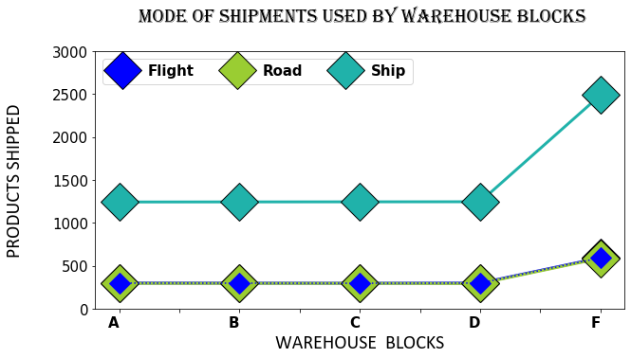

In [31]:

*#DISCOUNT OFFERED BY WAREHOUSE BLOCKS*

plt.figure(figsize**=**(10,6))

font1**=**{'family':'Algerian','color':'black','size':20,'fontweight':'bold'}

font2**=**{'family':'Calibri','color':'black','size':20}

plt.title("DISCOUNT OFFERED BY WAREHOUSE BLOCKS",fontdict**=**font1,pad**=**30) plt.xlabel("WAREHOUSE BLOCKS",fontdict**=**font2,labelpad**=**5)

plt.xticks(color**=**'black', fontsize**=**'15',fontweight**=**'bold', horizontalalignment**=**'right') plt.yticks(color**=**'black', fontsize**=**'15', horizontalalignment**=**'right')

plt.ylabel("DISCOUNT OFFERED",fontdict**=**font2,labelpad**=**20)

plt.plot(d['Warehouse_block'],d['Discount_offered'],linewidth**=**3) plt.show()

*#Conclusion:Warehouse blocks A and B gave the highest discounts.*

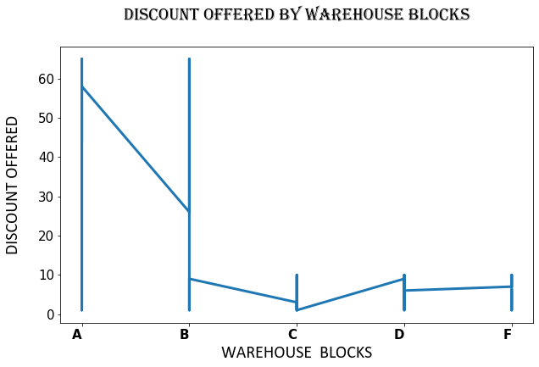

In [32]:

*#Customer Care calls received by warehouse blocks*

d1**=**df.copy()

grouped**=**pd.DataFrame(d1.groupby(['Warehouse_block'])['Customer_care_calls'].sum())

lineplot**=**grouped.plot(figsize**=**(8,5), marker**=**'*',ms**=**30,mec**=**'k',linestyle**=**'-',linewidth**=**2,mfc**=**'yellow',color**=**'blac font1**=**{'family':'Algerian','color':'black','size':20,'fontweight':'bold'}

font2**=**{'family':'Calibri','color':'black','size':20}

plt.title("CUSTOMER CARE CALLS RECEIVED BY WAREHOUSE BLOCKS",fontdict**=**font1,pad**=**30)

plt.xlabel("WAREHOUSE BLOCKS",fontdict**=**font2,labelpad**=**5) plt.ylabel("CALLS",fontdict**=**font2,labelpad**=**20)

plt.xticks(color**=**'black', fontsize**=**'15',fontweight**=**'bold', horizontalalignment**=**'right') plt.yticks(color**=**'black', fontsize**=**'15', horizontalalignment**=**'right')

plt.ylim(5000,17000) plt.show()

*#Conclusion: Warehouse Block 'F' has received the highest Customer Care calls*

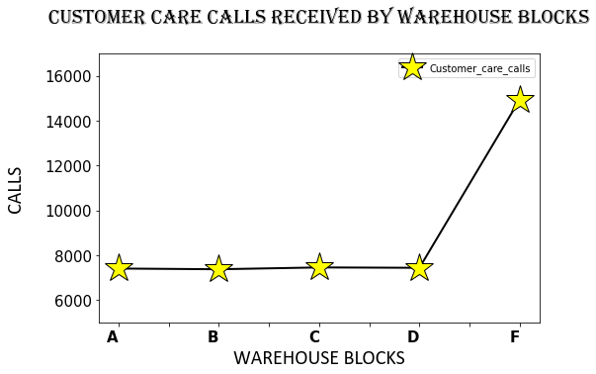

## Bar plots

*#Customer ratings 1-5 given to all the warehouse blocks*

plt.style.use('seaborn-pastel')

ctab**=**pd.crosstab(d['Warehouse_block'],d['Customer_rating'])

*#c=['tomato','skyblue','blue','seagreen','gold',slateblue]*

barplot**=**ctab.plot.bar(figsize**=**(15,6),edgecolor**=**'black',linewidth**=**2,width**=**0.5) font1**=**{'family':'Algerian','color':'black','size':20,'fontweight':'bold'}

font2**=**{'family':'Calibri','color':'black','size':20}

plt.title("CUSTOMER CARE RATING RECEIVED BY WAREHOUSE BLOCKS",fontdict**=**font1,pad**=**30)

plt.xlabel("WAREHOUSE BLOCKS",fontdict**=**font2,labelpad**=**5) plt.ylabel("NUMBER OF RATING",fontdict**=**font2,labelpad**=**20)

plt.xticks(color**=**'black', rotation**=**360, fontsize**=**'15',fontweight**=**'bold', horizontalalignment**=**'right') plt.yticks(color**=**'black', fontsize**=**'15', horizontalalignment**=**'right')

plt.legend(fontsize**=**15,title**=**'RATING',ncol**=**5) plt.show()

*#Conclusion:*

*#Warehouse Block 'A' and 'B' has received the highest rating of '3' #Warehouse Block 'B' has received the highest rating of '2' and '4' #Warehouse Block 'D' has received the highest rating of '5'*

*#Warehouse Block 'F' has received the highest rating of '1'*

*#Among all the blocks, 'F' has received the highest rating of '1','2','3','4','5'*

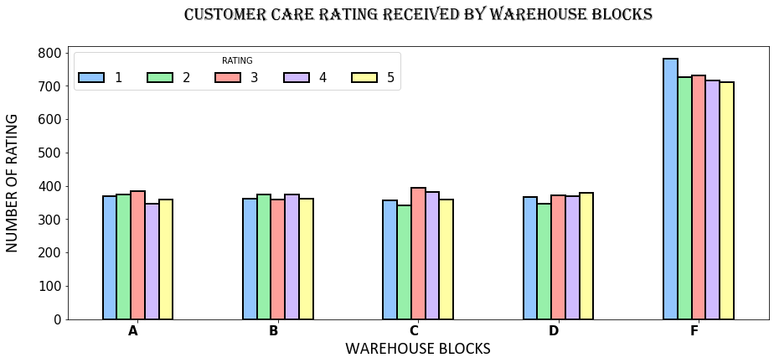

In [34]:

*#Warehouse blocks and different weights of products shipped*

plt.figure(figsize**=**(10,5))

warehouse**=**d.groupby(['Warehouse_block'])

*#warehouse.max().sort_values(by="Weight_in_gms",ascending=False)["Weight_in_gms"].plot.bar(edgecolor='k',linewid*

weight**=**warehouse.max().sort_values(by**=**"Weight_in_gms",ascending**=False**) weight["Weight_in_gms"].plot.bar(edgecolor**=**'k')

font1**=**{'family':'Algerian','color':'black','size':20,'fontweight':'bold'}

font2**=**{'family':'Calibri','color':'black','size':20}

plt.title("WAREHOUSE BLOCKS AND PRODUCT WEIGHT IN GMS",fontdict**=**font1,pad**=**30) plt.xlabel("WAREHOUSE BLOCKS",fontdict**=**font2,labelpad**=**20)

plt.ylabel(" WEIGHT SHIPPED IN gms",fontdict**=**font2,labelpad**=**20)

plt.xticks(color**=**'black', rotation**=**360, fontsize**=**'15',fontweight**=**'bold', horizontalalignment**=**'right') plt.yticks(color**=**'black', fontsize**=**'15', horizontalalignment**=**'right')

plt.show()

*#Conclusion:Warehouse Block A has shipped a product that has the heaviest weight among all the products. #Remaining warehouse blocks have shipped equal weights.*

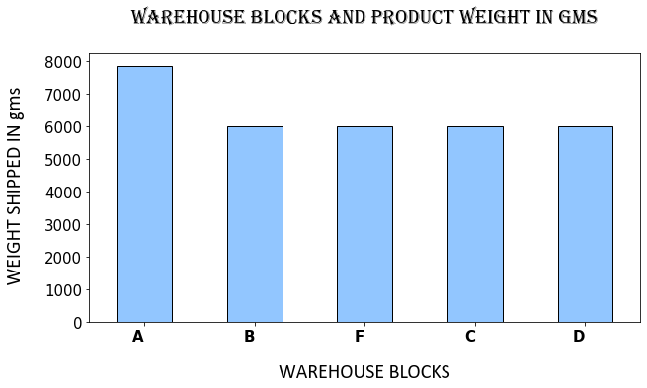

In [35]:

*#Products reached on time is denoted by 1 and products not reached on time is denoted by 0*

ctab**=**pd.crosstab(d['Warehouse_block'],d['Reached.on.Time_Y.N'])

barplot**=**ctab.plot.bar(figsize **=** (10,5),edgecolor**=**'black',color**=**['gold','tab:red'],linewidth**=**3) plt.title("WAREHOUSE BLOCKS AND PRODUCTS REACHED ON TIME",fontdict**=**font1,pad**=**30)

plt.xlabel("WAREHOUSE BLOCKS",fontdict**=**font2,labelpad**=**5) plt.ylabel(" PRODUCTS",fontdict**=**font2,labelpad**=**20)

plt.xticks(color**=**'black', rotation**=**360, fontsize**=**'15',fontweight**=**'bold', horizontalalignment**=**'right') plt.yticks(color**=**'black', fontsize**=**'15', horizontalalignment**=**'right')

legend_drawn_flag **= True**

plt.legend(['NO','YES'],title**=**'REACHED ON TIME',bbox_to_anchor **=**(1.35, 1),loc**=**'upper right',ncol**=**2, prop **=** {'size' : 15,'weight':'bold'},frameon**=**legend_drawn_flag)

plt.show()

*#Conclusion: Warehouse block A has delivered all the products on time. #Warehouse block F has not delivered most of the products on time.*

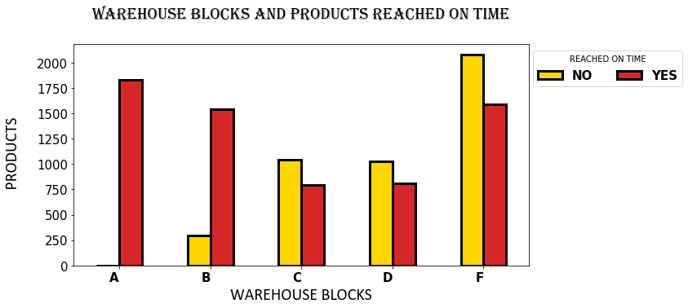

In [36]:

*#low,Medium,High importance products delivered by all the warehouse blocks*

ctab**=**pd.crosstab(d['Warehouse_block'],d['Product_importance'])

barplot**=**ctab.plot.bar(figsize **=** (15,5),edgecolor**=**'black',color**=**['silver', 'aquamarine', 'seagreen'],linewidth**=**3) plt.title("WAREHOUSE BLOCKS AND PRODUCT IMPORTANCE",fontdict**=**font1,pad**=**30)

plt.xlabel("WAREHOUSE BLOCKS",fontdict**=**font2,labelpad**=**5)

plt.ylabel(" PRODUCT IMPORTANCE",fontdict**=**font2,labelpad**=**20)

plt.xticks(color**=**'black', rotation**=**360, fontsize**=**'15',fontweight**=**'bold', horizontalalignment**=**'right') plt.yticks(color**=**'black', fontsize**=**'15', horizontalalignment**=**'right')

plt.legend(fontsize**=**15,ncol**=**3,title**=**'PRODUCT IMPORTANCE',prop **=** {'size' : 15,'weight':'bold'}) plt.show()

*#Conclusion:Warehouse block A,B,D,F has shipped most of the products of low importance. #Warehouse block C has shipped most of the products of low and medium importance.*

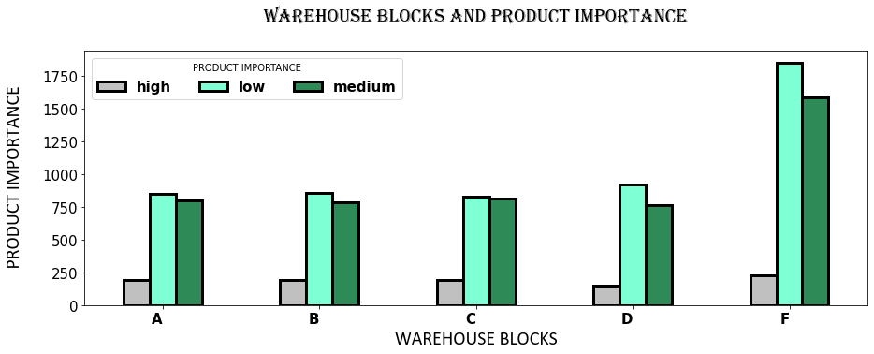

## Histogram

*#Product weight in gms shipped by all the Warehouse blocks*

plt.figure(figsize**=**(10,5)) bins**=**[0,1000,2000,4000,6000]

plt.hist(d['Weight_in_gms'],bins,histtype**=**'bar',rwidth**=**0.6,color**=**'mediumpurple',edgecolor**=**'black')*#rectangular w*

plt.title("PRODUCT WEIGHT IN GMS ",fontdict**=**font1,pad**=**30) plt.xlabel("RANGE",fontdict**=**font2,labelpad**=**20)

plt.ylabel(" PRODUCT WEIGHT IN GMS",fontdict**=**font2,labelpad**=**20)

plt.xticks(color**=**'black', rotation**=**360, fontsize**=**'15',fontweight**=**'bold', horizontalalignment**=**'right') plt.yticks(color**=**'black', fontsize**=**'15', horizontalalignment**=**'right')

plt.show()

*#Conclusion: Heavy products were shipped by most of the blocks*

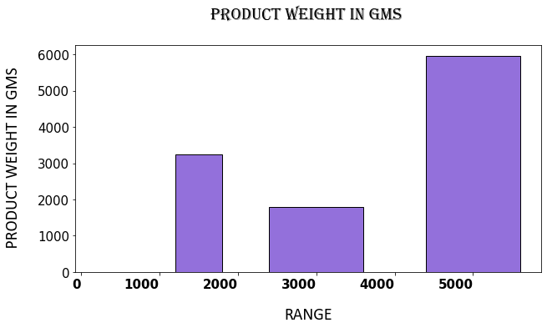

# Seaborn

## Catplot

*#Mode of Shipment and Weight in gms*

import seaborn as sns

plt.style.use('seaborn-bright')

sns.set_style("ticks")

plt.style.use('seaborn-bright')

sns.catplot(y="Weight_in_gms",x='Mode_of_Shipment',hue='Mode_of_Shipment',data=d,height=5,aspect=15/10)

plt.title("MODE OF SHIPMENT AND WEIGHT IN gms ",fontdict=font1,pad=30)

plt.xlabel("MODE OF SHIPMENT",fontdict=font2,labelpad=20)

plt.ylabel("WEIGHT IN gms ",fontdict=font2,labelpad=20)

plt.xticks(color='black',fontsize='15',fontweight='bold')

plt.yticks(color='black', fontsize='15')

plt.legend(fontsize=15,bbox_to_anchor =(1.15, 1),loc='upper right')

plt.show()

*#Conclusion: From the graph we can see that the density of ship mode is more.*

*#Most of the Warehouse blocks have used Ship mode to deliver the products.*

*#Few of the heavy products weighing more than 7000gms was shipped through Ship mode.*

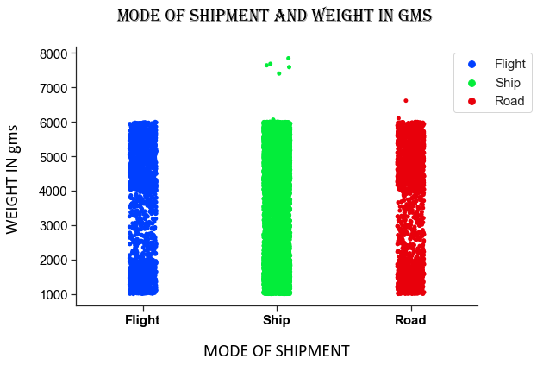

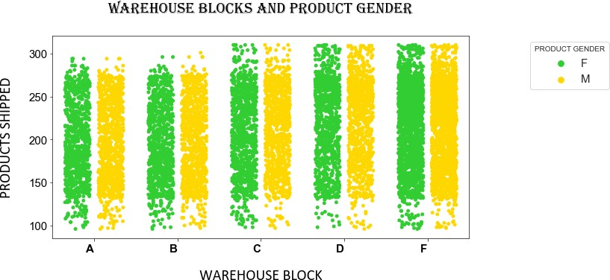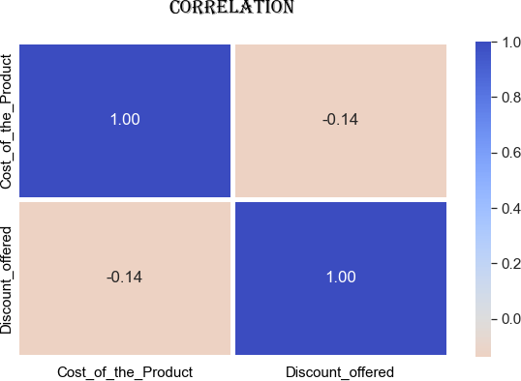 **STRIPPLOT**

*#HEATMAP*

*#Correlation between the cost of the product and discount*

plt.figure(figsize**=**(10,6)) sns.set(font_scale**=**1.4)

n_data**=**['Cost_of_the_Product','Discount_offered']

sns.heatmap(d[n_data].corr(),annot**=True**,fmt**=**'.2f',cmap**=**'coolwarm_r',center**=**0,linewidths**=**5) plt.title("Correlation",fontdict**=**font1,pad**=**30)

plt.xticks(color**=**'black', horizontalalignment**=**'center', fontsize**=**15) plt.yticks(color**=**'black', horizontalalignment**=**'center',fontsize**=**15) plt.show()

*#Cost of the product and discount offered is negatively correlated.*

*#STRIP PLOT*

*#WAREHOUSE BLOCKS AND PRODUCT GENDER*

custom_palette **=** ["limegreen","gold"] sns.set_palette(custom_palette)

plt.figure(figsize**=**(10,5))

sns.stripplot(x**=**'Warehouse_block',y**=**'Cost_of_the_Product',hue**=**"Gender",jitter**=**0.3,dodge**=True**, data**=**d) plt.title("WAREHOUSE BLOCKS AND PRODUCT GENDER",fontdict**=**font1,pad**=**30)

plt.xlabel("WAREHOUSE BLOCK",fontdict**=**font2,labelpad**=**20) plt.ylabel("PRODUCTS SHIPPED",fontdict**=**font2,labelpad**=**20)

plt.xticks(color**=**'black',fontsize**=**'15',fontweight**=**'bold', horizontalalignment**=**'right') plt.yticks(color**=**'black', fontsize**=**'15', horizontalalignment**=**'right')

plt.legend(fontsize**=**15,bbox_to_anchor **=**(1.35, 1),loc**=**'upper right',frameon**=True**,title**=**'PRODUCT GENDER') plt.show()

*#Conclusion: All the Warehouse blocks has shipped equal products of Female and Male Gender.*

**HEATMAP**

**from** pandas_profiling **import** ProfileReport

k**=**ProfileReport(d)

k.to_file('Report.html')

k

|  |  |  |  |  |  |
| --- | --- | --- | --- | --- | --- |
| Overview | Variables | Correlations | Missing values | Sample |  |
| Dataset info  **Number of variables** 10  **Number of observations** 10999  **Missing cells** 0 (0.0%)  **Duplicate rows** 0 (0.0%)  **Total size in memory** 3.0 MiB  **Average record size in memory** 286.7 B  Variables types  **NUM** 5  **CAT** 4  **BOOL** 1  Toggle Reproduction Information | | | | | |

**SUMMARY**

The Analysis of the E-Commerce Shipping Statistics

1. The Warehouse blocks prefer Ship mode as the shipping method for most of the products.
2. We can also observe that Warehouse blocks A,B delivered the products on time and Warehouse blocks C,D,F, did not deliver most of the products on time.
3. Customer care calls was received more by the Warehouse Block F.
4. High customer rating as well as low customer rating was given to Warehouse block F.

Improvement 1: Change in Mode of Shipment Required

We can see most of the Warehouse blocks did not deliver the product on time because the mode of shipping was through Ship.

Although ships are capable of carrying much bigger loads than other transportation methods, shipping takes much longer.

It is not usually the preferred shipping method for businesses that rely on speedy delivery. The shipping mode should be changed to other modes of transport like Road or Flight, so that the products reaches the customer on time. According to a recent study, 98% of consumers are likely to order again from a website if the delivery experience went well.

Improvement 2: Customer Care Required

We can observe that Warehouse Block F has received more calls from the customers. It has also received a high customer rating of 1 out of 5. This clearly shows that the customers are not happy with the products delivered. Feedback has to be taken from the customer and make necessary changes in order to improve the overall customer experience. More Customer service executives has to be assigned to the Warehouse block F.

Conclusion:

Logistics is a major pillar of the e-commerce customer experience. Optimizing logistics is an important factor for the success of any brand. In order to retain the customers and attract new ones, it is important to optimize the processes at different levels: delivery, packaging, returns, customer service.

**REFERENCES**

<https://www.kaggle.com/>

<https://matplotlib.org/>

<https://seaborn.pydata.org/>